
How to add a custom library to MCUEXPRESSO
Advanced Embedded Systems

Authors: Dr. Gilberto Ochoa Ruiz
Msc. Jorge German Perez Blanco
Contents
Introduction 3
Adding a library that you have the source code 3
Adding a static library to your project 4
Example application 6
Annexes 7
Other Resources 7
Example application code 7
HCSR04.h 7
HCSR04.c 8
Main app code 11

Introduction
In the ever-evolving landscape of embedded systems, microcontroller units (MCUs) serve as the heartbeat of countless devices, ranging from simple household appliances to complex industrial machinery. As the demand for smarter, more interconnected devices grows, so too does the complexity of embedded programming. At the core of this complexity lies the efficient utilization of resources, streamlined development processes, and the ability to harness the full potential of the hardware. Herein lies the pivotal role of libraries in MCU embedded programming.
Libraries, in the context of embedded systems, encapsulate pre-written code modules designed to perform specific tasks or functions. They provide developers with a treasure trove of pre-tested and optimized code, offering solutions to common challenges encountered during MCU programming. Whether it's interfacing with peripherals, implementing communication protocols, or managing low-level hardware resources, libraries serve as invaluable building blocks, enabling developers to focus on application logic rather than reinventing the wheel.
The utilization of libraries not only accelerates development cycles but also enhances code reliability and maintainability. By leveraging well-established libraries, developers can tap into the collective wisdom of the embedded community, benefiting from peer-reviewed code and best practices. Moreover, libraries abstract away hardware intricacies, fostering portability across different MCU platforms and facilitating code reuse—a fundamental principle in software engineering.
Whether you want to use in your code your own libraries, or those developed by the community, this guide will allow you to know the steps to follow to master the use of the libraries in the MCUExpresso IDE.

Adding a library that you have the source code
If you were the developer of the library or have access to the source code, you can choose this option. To do this you must first add the .h and .c files to the sources folder. To locate the source folder in your file system, in the Developer Perspective of the MCUExpresso, first locate the Project Explorer tab, at the upper left portion of the screen. Then double click in the folder of the project that you want to add the library. Then right click the source folder and select the Show in option from the dropdown menu. Then click on the System Explorer option from the dropdown menu as seen in the following image.
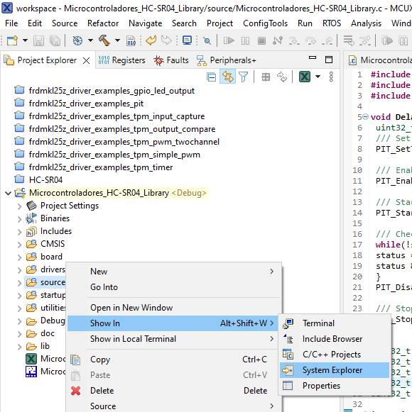
The result should look something like show in the following image.
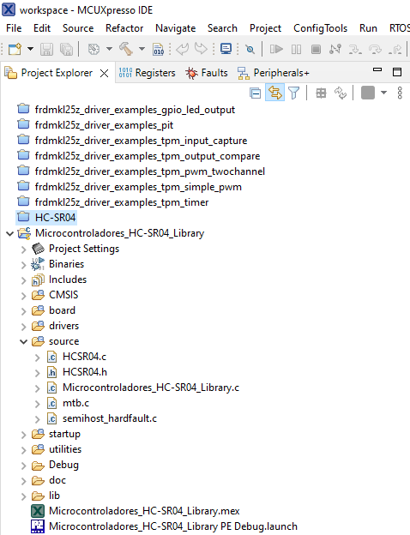
Open the source file of your main application code and include de header file (.h) of the library in your code. Then you will be able to use all the functions included in the library. An example is shown in the following image.
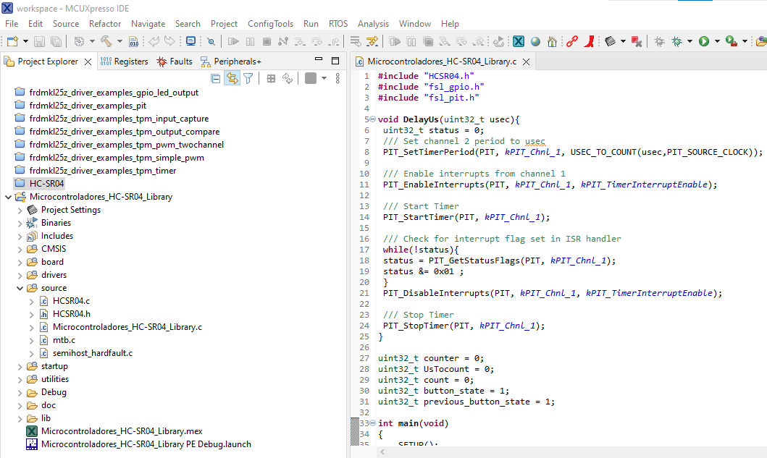

Adding a static library to your project
To use a static library in your code you need access to the library file (.a) and its header (h). Paste the header file in the source folder of your project, create a library folder called lib for example, and paste the library file inside that folder. Previously was explain how to access to your project folder from the IDE MCUExpresso. The result should look something like show in the following image.
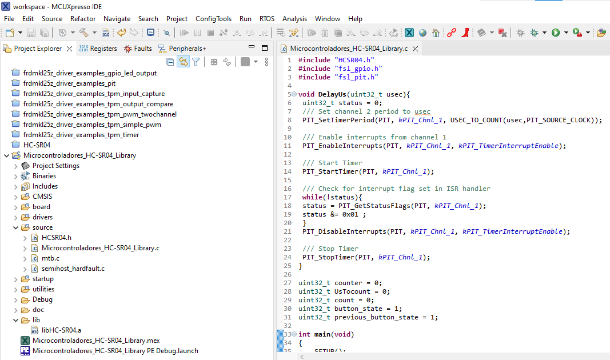
Next step is to add the library path to the linker in the properties settings. To access the properties window you should right click on the project and select the Properties option from the dropdown menu, as shown in the following image.
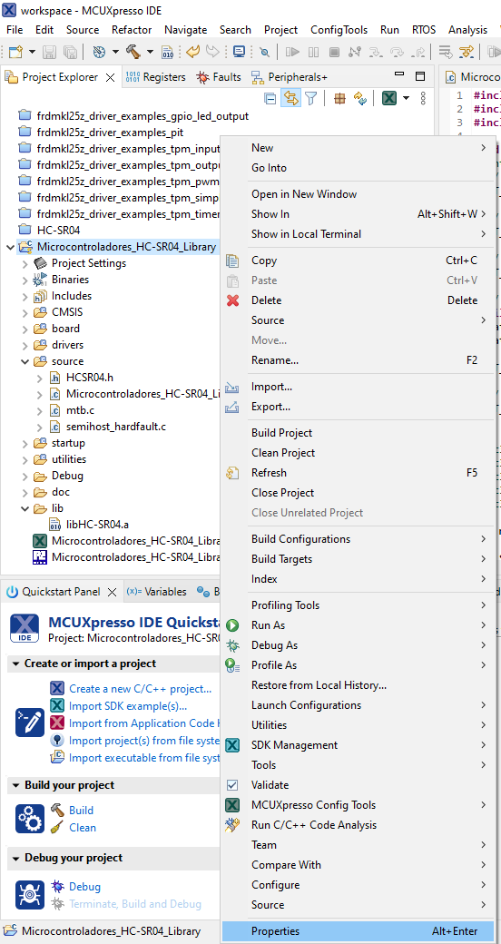
In the Properties window of the project, select C/C++ Build, then click on the Settings option, then under the MCU Linker option click on Libraries. Next add the library and the search path for the library using the add button as shown in the following image.
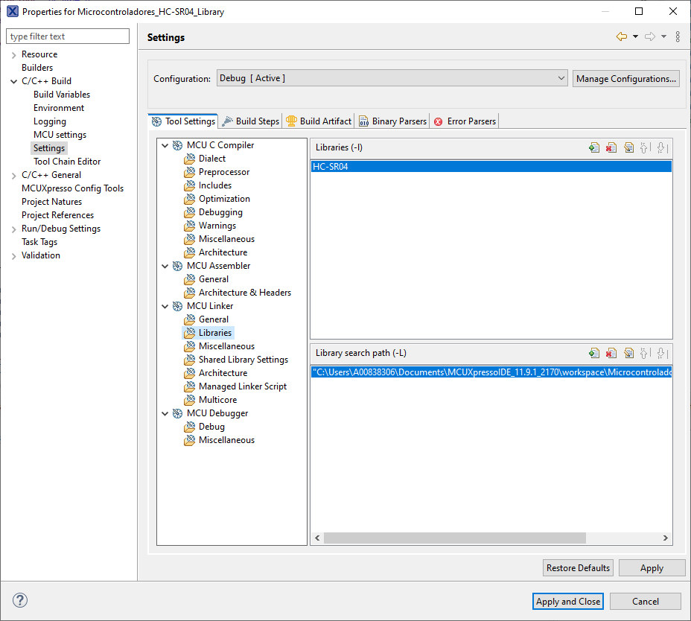

NOTE: We only specify library_name in Libraries (-l). For example, if you have a library called libHC-SR04.a, we specify HC-SR04 in the Linker Libraries settings. We also need to specify the location that we have placed the library archive in the Library search path (-L) setting.
Open the source file of your main application code and include de header file (.h) of the library in your code. Then you will be able to use all the functions included in the library, you can even debug your code and step into the functions includes on the library. An example is shown in the following image.
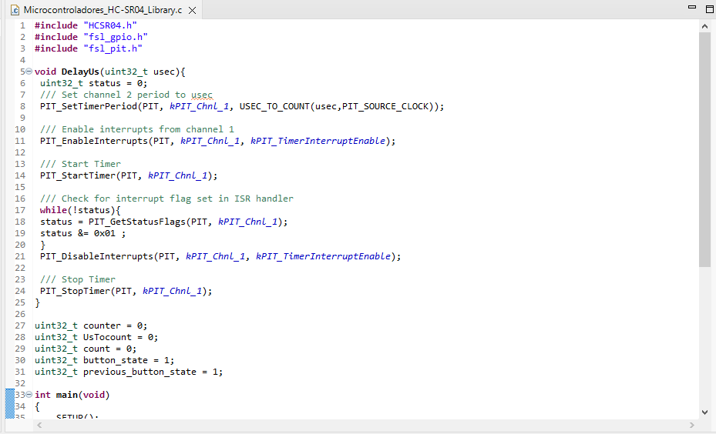

Example application
An example library was developed to illustrate the use of libraries on the MCUExpresso. The Example code is provided on the Annexes. This library enables to manage the LCD display 1602A. It has basic functionalities to configure and control the display, it also includes some functions that encapsulate the basic functionalities to use the device in an easier way. The config_LCD function allows to specify the port that will be use for data, the port that will be use for control, the specific pins in the port that will be used for RS, RW and EN signals, and also allows to specify the data length (4 or 8 bits). The basic function send_command allows to send a command to the LCD but the user must know the specific available commands in order to use it. Several helper functions for specific porpouse were added, such as clear_display, return_home, display_on, display_off. They all, internally, make use of the previous mentioned send_command function. The send_data function allows to send a single character to be print on the LCD display.

Annexes

Other Resources
You can find a guide for the process of compiling and using your own static library in MCUExpresso in the following link: https://community.nxp.com/pwmxy87654/attachments/pwmxy87654/mcuxpresso-ide%40tkb/478/1/How%20to%20create%20and%20use%20static%20library%20in%20MCUXpresso%20IDE%20-%20ver3.pdf

Example application code

LCD1602A.h
/*
* Example Library to interface the 1602A LCD display with MCUExpresso
*/
#ifndef _LCD1602A_H_
#define _LCD1602A_H_
/*******************************************************************************
* Definitions
******************************************************************************/
#define RS_PIN 2 /* PTA2 mask */
#define RW_PIN 4 /* PTA4 mask */
#define EN_PIN 5 /* PTA5 mask */

/*******************************************************************************
* Prototypes
******************************************************************************/
extern void delayMs(int n);
extern void config_LCD(GPIO_Type * data_port, uint8_t data_size, GPIO_Type * control_port, uint32_t RS_pin, uint32_t RW_pin, uint32_t E_pin);
extern void send_command(uint8_t command);
extern void LCD_ready();
extern void LCD_data_direction(GPIO_Type * data_port, uint8_t direction, uint8_t data_size);
extern void send_data(unsigned char data);
extern void clear_display();
extern void return_home();
extern void display_on();
extern void display_off();
extern void set_data_width(uint8_t width);

// /*******************************************************************************
// * Variables
// ******************************************************************************/
extern GPIO_Type * Data_Port;
extern GPIO_Type * Control_Port;
extern uint8_t data_size;

#endif

LCD1602A.c
#include <stdio.h>
#include "board.h"
#include "pin_mux.h"
#include "clock_config.h"
#include "MKL25Z4.h"
#include "fsl_debug_console.h"
/* TODO: insert other include files here. */
#include "fsl_port.h"
#include "LCD1602A.h"

/*******************************************************************************
* Variables
******************************************************************************/
GPIO_Type * Data_Port = GPIOD;
GPIO_Type * Control_Port = GPIOA;
uint8_t data_size = 8;

/*******************************************************************************
* Code
******************************************************************************/
void config_LCD(GPIO_Type * data_port, uint8_t data_size, GPIO_Type * control_port, uint32_t RS_pin, uint32_t RW_pin, uint32_t E_pin)
{
/* Init code */
SIM->SCGC6 |= 0x01000000; /* enable clock to TPM0 */
SIM->SOPT2 |= 0x01000000; /* use 32.76khz as clock */
TPM0->SC = 0; /* disable timer while configuring */
TPM0->SC = 0x02; /* prescaler /4 */
TPM0->MOD = 0x2000; /* max modulo value 8192*/
TPM0->SC |= 0x80; /* clear TOF */
TPM0->SC |= 0x08; /* enable timer free-running mode */

switch((uint32_t)data_port)
{
case GPIOA_BASE:
CLOCK_EnableClock(kCLOCK_PortA);
PORT_SetPinMux(PORTA, 0u, kPORT_MuxAsGpio);
PORT_SetPinMux(PORTA, 1u, kPORT_MuxAsGpio);
PORT_SetPinMux(PORTA, 2u, kPORT_MuxAsGpio);
PORT_SetPinMux(PORTA, 3u, kPORT_MuxAsGpio);
if (data_size == 8)
{
PORT_SetPinMux(PORTA, 4u, kPORT_MuxAsGpio);
PORT_SetPinMux(PORTA, 5u, kPORT_MuxAsGpio);
PORT_SetPinMux(PORTA, 6u, kPORT_MuxAsGpio);
PORT_SetPinMux(PORTA, 7u, kPORT_MuxAsGpio);
}
break;
case GPIOB_BASE:
CLOCK_EnableClock(kCLOCK_PortB);
PORT_SetPinMux(PORTB, 0u, kPORT_MuxAsGpio);
PORT_SetPinMux(PORTB, 1u, kPORT_MuxAsGpio);
PORT_SetPinMux(PORTB, 2u, kPORT_MuxAsGpio);
PORT_SetPinMux(PORTB, 3u, kPORT_MuxAsGpio);
if (data_size == 8)
{
PORT_SetPinMux(PORTB, 4u, kPORT_MuxAsGpio);
PORT_SetPinMux(PORTB, 5u, kPORT_MuxAsGpio);
PORT_SetPinMux(PORTB, 6u, kPORT_MuxAsGpio);
PORT_SetPinMux(PORTB, 7u, kPORT_MuxAsGpio);
}
break;
case GPIOC_BASE:
CLOCK_EnableClock(kCLOCK_PortC);
PORT_SetPinMux(PORTC, 0u, kPORT_MuxAsGpio);
PORT_SetPinMux(PORTC, 1u, kPORT_MuxAsGpio);
PORT_SetPinMux(PORTC, 2u, kPORT_MuxAsGpio);
PORT_SetPinMux(PORTC, 3u, kPORT_MuxAsGpio);
if (data_size == 8)
{
PORT_SetPinMux(PORTC, 4u, kPORT_MuxAsGpio);
PORT_SetPinMux(PORTC, 5u, kPORT_MuxAsGpio);
PORT_SetPinMux(PORTC, 6u, kPORT_MuxAsGpio);
PORT_SetPinMux(PORTC, 7u, kPORT_MuxAsGpio);
}
break;
case GPIOD_BASE:
CLOCK_EnableClock(kCLOCK_PortD);
PORT_SetPinMux(PORTD, 0u, kPORT_MuxAsGpio);
PORT_SetPinMux(PORTD, 1u, kPORT_MuxAsGpio);
PORT_SetPinMux(PORTD, 2u, kPORT_MuxAsGpio);
PORT_SetPinMux(PORTD, 3u, kPORT_MuxAsGpio);
if (data_size == 8)
{
PORT_SetPinMux(PORTD, 4u, kPORT_MuxAsGpio);
PORT_SetPinMux(PORTD, 5u, kPORT_MuxAsGpio);
PORT_SetPinMux(PORTD, 6u, kPORT_MuxAsGpio);
PORT_SetPinMux(PORTD, 7u, kPORT_MuxAsGpio);
}
break;
case GPIOE_BASE:
CLOCK_EnableClock(kCLOCK_PortE);
PORT_SetPinMux(PORTE, 0u, kPORT_MuxAsGpio);
PORT_SetPinMux(PORTE, 1u, kPORT_MuxAsGpio);
PORT_SetPinMux(PORTE, 2u, kPORT_MuxAsGpio);
PORT_SetPinMux(PORTE, 3u, kPORT_MuxAsGpio);
if (data_size == 8)
{
PORT_SetPinMux(PORTE, 4u, kPORT_MuxAsGpio);
PORT_SetPinMux(PORTE, 5u, kPORT_MuxAsGpio);
PORT_SetPinMux(PORTE, 6u, kPORT_MuxAsGpio);
PORT_SetPinMux(PORTE, 7u, kPORT_MuxAsGpio);
}
break;
}

switch((uint32_t)control_port)
{
case GPIOA_BASE:
CLOCK_EnableClock(kCLOCK_PortA);
PORT_SetPinMux(PORTA, RS_pin, kPORT_MuxAsGpio);
PORT_SetPinMux(PORTA, RW_pin, kPORT_MuxAsGpio);
PORT_SetPinMux(PORTA, E_pin, kPORT_MuxAsGpio);
break;
case GPIOB_BASE:
CLOCK_EnableClock(kCLOCK_PortB);
PORT_SetPinMux(PORTB, RS_pin, kPORT_MuxAsGpio);
PORT_SetPinMux(PORTB, RW_pin, kPORT_MuxAsGpio);
PORT_SetPinMux(PORTB, E_pin, kPORT_MuxAsGpio);
break;
case GPIOC_BASE:
CLOCK_EnableClock(kCLOCK_PortC);
PORT_SetPinMux(PORTC, RS_pin, kPORT_MuxAsGpio);
PORT_SetPinMux(PORTC, RW_pin, kPORT_MuxAsGpio);
PORT_SetPinMux(PORTC, E_pin, kPORT_MuxAsGpio);
break;
case GPIOD_BASE:
CLOCK_EnableClock(kCLOCK_PortD);
PORT_SetPinMux(PORTD, RS_pin, kPORT_MuxAsGpio);
PORT_SetPinMux(PORTD, RW_pin, kPORT_MuxAsGpio);
PORT_SetPinMux(PORTD, E_pin, kPORT_MuxAsGpio);
break;
case GPIOE_BASE:
CLOCK_EnableClock(kCLOCK_PortE);
PORT_SetPinMux(PORTE, RS_pin, kPORT_MuxAsGpio);
PORT_SetPinMux(PORTE, RW_pin, kPORT_MuxAsGpio);
PORT_SetPinMux(PORTE, E_pin, kPORT_MuxAsGpio);
break;
}

gpio_pin_config_t config;
config.outputLogic = 0;
config.pinDirection = kGPIO_DigitalOutput;

LCD_data_direction(data_port, 1, data_size);

GPIO_PinInit(control_port, RS_pin, &config);
GPIO_PinInit(control_port, RW_pin, &config);
GPIO_PinInit(control_port, E_pin, &config);

delayMs(20); /* initialization sequence */
/* LCD does not respond to status poll */
send_command(0x30);
delayMs(5);
send_command(0x30);
delayMs(1);
send_command(0x30);
/* set 8-bit data, 2-line, 5x7 font */
send_command(0x38);
/* move cursor right */
send_command(0x06);
/* clear screen, move cursor to home */
send_command(0x01);
/* turn on display, cursor blinking */
send_command(0x0F);
}

void send_command(uint8_t command)
{
LCD_ready();
LCD_data_direction(Data_Port, 1, data_size);

GPIO_WritePinOutput(Control_Port, RS_PIN, 0); /* RS = 0*/
GPIO_WritePinOutput(Control_Port, RW_PIN, 0); /*, R/W = 0 */
LCD_data_direction(Data_Port, 1, data_size);

switch((uint32_t)Data_Port)
{
case GPIOA_BASE:
PTA->PDOR = command;
break;
case GPIOB_BASE:
PTB->PDOR = command;
break;
case GPIOC_BASE:
PTC->PDOR = command;
break;
case GPIOD_BASE:
PTD->PDOR = command;
break;
case GPIOE_BASE:
PTE->PDOR = command;
break;
}

GPIO_WritePinOutput(Control_Port, EN_PIN, 1); /* pulse E */
delayMs(1);
GPIO_WritePinOutput(Control_Port, EN_PIN, 0);

}

void LCD_data_direction(GPIO_Type * data_port, uint8_t direction, uint8_t data_size)
{
gpio_pin_config_t config;
config.outputLogic = 0;
if (direction == 1)
config.pinDirection = kGPIO_DigitalOutput;
else
if(direction == 0)
config.pinDirection = kGPIO_DigitalInput;

GPIO_PinInit(data_port, 0, &config);
GPIO_PinInit(data_port, 1, &config);
GPIO_PinInit(data_port, 2, &config);
GPIO_PinInit(data_port, 3, &config);

if (data_size == 8)
{
GPIO_PinInit(data_port, 4, &config);
GPIO_PinInit(data_port, 5, &config);
GPIO_PinInit(data_port, 6, &config);
GPIO_PinInit(data_port, 7, &config);
}

}

void LCD_ready(void)
{
char status;

LCD_data_direction(Data_Port, 0, data_size);
GPIO_WritePinOutput(Control_Port, RS_PIN, 0); //RS = 0 for status
GPIO_WritePinOutput(Control_Port, RW_PIN, 1);// R/W = 1, LCD output
do { /* stay in the loop until it is not busy */
GPIO_WritePinOutput(Control_Port, EN_PIN, 1); /* raise E */
delayMs(1);
status = GPIO_ReadPinInput(Data_Port, 7); /* read BF */
GPIO_WritePinOutput(Control_Port, EN_PIN, 0); /* lower E */
delayMs(1); /* clear E */
} while (status == 1); /* check busy bit */

GPIO_WritePinOutput(Control_Port, RW_PIN, 0);/* R/W = 0, LCD input */
LCD_data_direction(Data_Port, 1, data_size); /* PortD output */
}

void send_data(unsigned char data)
{
LCD_ready(); /* wait until LCD is ready */
LCD_data_direction(Data_Port, 1, data_size); /*configure port data as output*/

GPIO_WritePinOutput(Control_Port, RS_PIN, 1); /* RS = 1*/
GPIO_WritePinOutput(Control_Port, RW_PIN, 0); /* RW = 0*/

switch((uint32_t)Data_Port)
{
case GPIOA_BASE:
PTA->PDOR = data;
break;
case GPIOB_BASE:
PTB->PDOR = data;
break;
case GPIOC_BASE:
PTC->PDOR = data;
break;
case GPIOD_BASE:
PTD->PDOR = data;
break;
case GPIOE_BASE:
PTE->PDOR = data;
break;
}

GPIO_WritePinOutput(Control_Port, EN_PIN, 1); /* pulse E */
delayMs(1);
GPIO_WritePinOutput(Control_Port, EN_PIN, 0);
}

/* Delay function */
void delayMs(int n) {
for(int i = 0; i < n; i++)
{
while((TPM0->SC & 0x80) == 0) { }
/* wait until the TOF is set */
TPM0->SC |= 0x80; /* clear TOF */
}
}

void clear_display()
{
send_command(0x01);
delayMs(5);
}

void return_home()
{
send_command(0x02);
delayMs(5);
}

void display_on()
{
send_command(0x0F);
delayMs(5);
}

void display_off()
{
send_command(0x0B);
delayMs(5);
}

void set_data_width(uint8_t width)
{
if(width == 4)
{
send_command(0b00101000);
delayMs(10);
data_size = 4;
}
else
{
if(width == 8)
{
send_command(0b00111000);
delayMs(10);
data_size = 8;
}
}
delayMs(5);
}

Main app code
/*
* Copyright 2016-2024 NXP
* All rights reserved.
*
* SPDX-License-Identifier: BSD-3-Clause
*/

/**
* @file Testing_LCD_Library.c
* @brief Application entry point.
*/
#include <stdio.h>
#include "board.h"
#include "peripherals.h"
#include "pin_mux.h"
#include "clock_config.h"
#include "MKL25Z4.h"
#include "fsl_debug_console.h"
/* TODO: insert other include files here. */
#include "LCD1602A.h"

/* TODO: insert other definitions and declarations here. */

/*
* @brief Application entry point.
*/
int main(void) {

/* Init board hardware. */
BOARD_InitBootPins();
BOARD_InitBootClocks();
BOARD_InitBootPeripherals();
#ifndef BOARD_INIT_DEBUG_CONSOLE_PERIPHERAL
/* Init FSL debug console. */
BOARD_InitDebugConsole();
#endif

config_LCD(Data_Port, 8, Control_Port, 2, 4, 5);

send_data('H');
send_data('e');
send_data('l');
send_data('l');
send_data('o');
delayMs(2000);
send_command(0x1C); //shift entire display right
delayMs(500);
send_command(0x1C); //shift entire display right
delayMs(500);
send_command(0x1C); //shift entire display right
delayMs(500);
send_command(0x1C); //shift entire display right
delayMs(500);
send_command(0x1C); //shift entire display right
delayMs(3000);

clear_display();
send_command(0x0C); //cursor off
send_command(0x14); //shift cursor right
send_command(0x14); //shift cursor right

send_data('T');
send_data('e');
send_data('s');
send_data('t');
send_data('i');
send_data('n');
send_data('g');
send_data(' ');
send_data('L');
send_data('C');
send_data('D');

send_command(0xC0);

send_command(0x14);//shift cursor right
send_command(0x14);//shift cursor right
send_command(0x14);//shift cursor right
send_command(0x14);//shift cursor right
send_command(0x14);//shift cursor right

send_data('d');
send_data('r');
send_data('i');
send_data('v');
send_data('e');
send_data('r');

/* Force the counter to be placed into memory. */
volatile static int i = 0 ;
/* Enter an infinite loop, just incrementing a counter. */
while(1) {
i++ ;
/* 'Dummy' NOP to allow source level single stepping of
tight while() loop */
__asm volatile ("nop");
}
return 0 ;
}

